

Semester Two Examination, 2020

Question/Answer booklet

MATHEMATICS SPECIALIST
UNITs 3 & 4

Section One:

Calculator-free

Your Name

Your Teacher’s Name

Time allowed for this section
Reading time before commencing work: five minutes
Working time: fifty minutes

Materials required/recommended for this section
To be provided by the supervisor
This Question/Answer booklet
Formula sheet

To be provided by the candidate
Standard items: pens (blue/black preferred), pencils (including coloured), sharpener, correction fluid/tape, eraser, ruler, highlighters

Special items: nil

Important note to candidates
No other items may be taken into the examination room. It is your responsibility to ensure that you do not have any unauthorised material. If you have any unauthorised material with you, hand it to the supervisor before reading any further.
Question | Mark | Max | Question | Mark | Max
1 |  | 6 | 5 |  | 6
2 |  | 5 | 6 |  | 11
3 |  | 9 | 7 |  | 6
4 |  | 7

Structure of this paper

Section | Number of questions available | Number of questions to be answered | Working time (minutes) | Marks available | Percentage of examination
Section One:  Calculator-free | 7 | 7 | 50 | 50 | 35
Section Two:  Calculator-assumed | 11 | 11 | 100 | 89 | 65
 |  |  |  | Total | 100

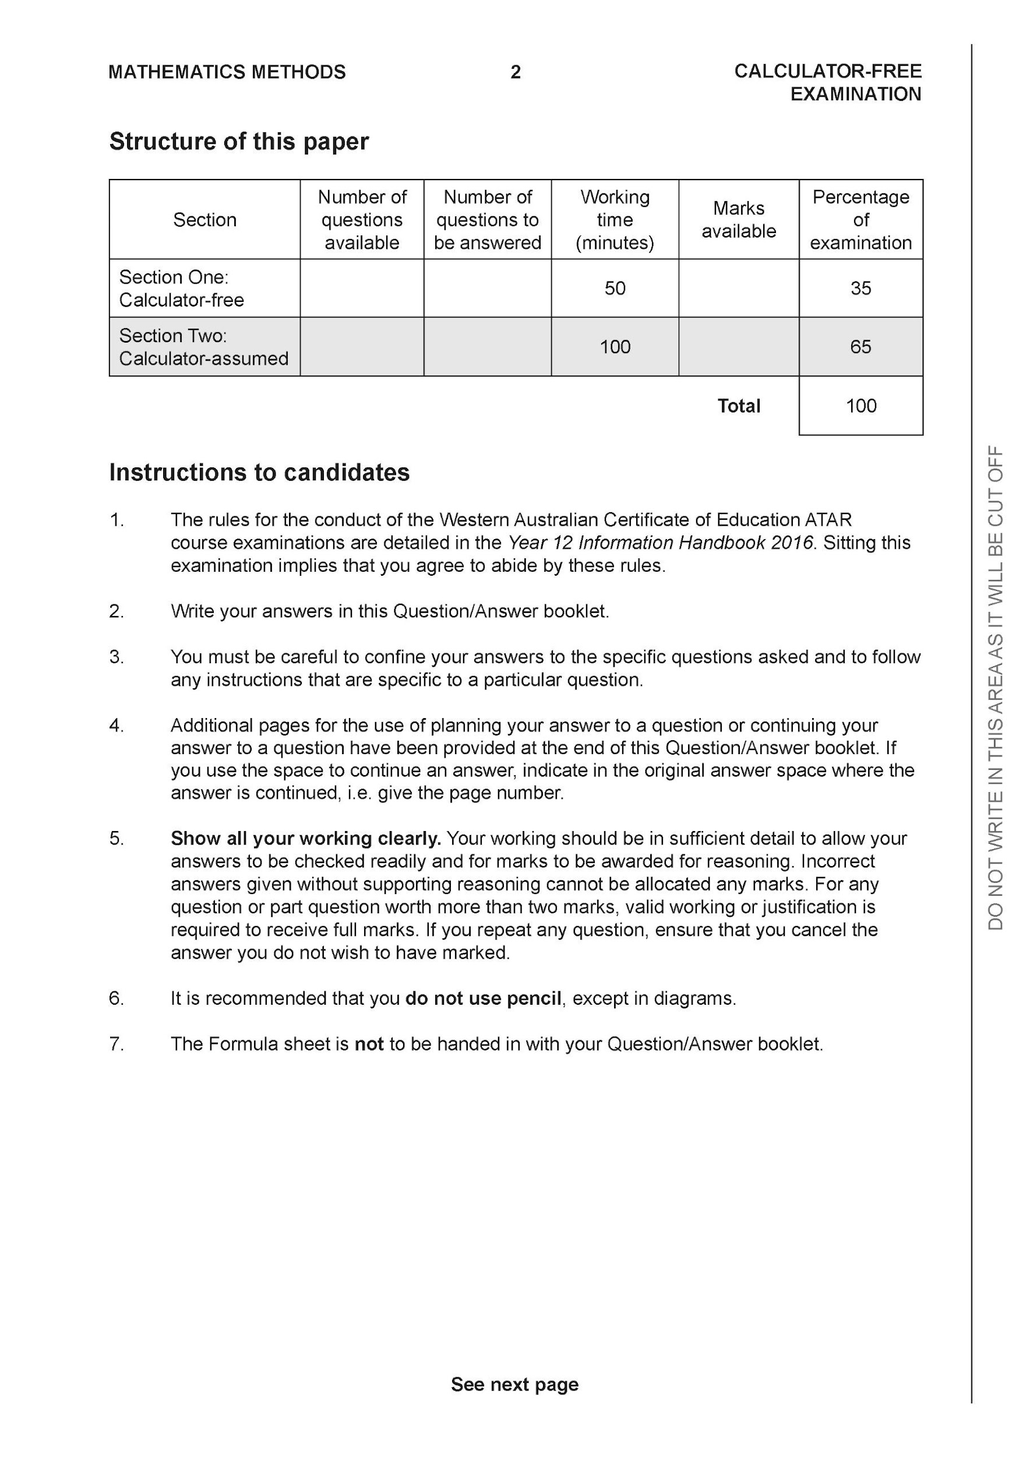

Section One: Calculator-free (50 Marks)

This section has seven (7) questions. Answer all questions. Write your answers in the spaces provided.

Spare pages are included at the end of this booklet. They can be used for planning your responses and/or as additional space if required to continue an answer.
● Planning: If you use the spare pages for planning, indicate this clearly at the top of the page.
● Continuing an answer: If you need to use the space to continue an answer, indicate in the original answer space where the answer is continued, i.e. give the page number. Fill in the number of the question that you are continuing to answer at the top of the page.

Working time: 50 minutes.

Question 1 (6 marks)
(a) (3 marks)

Solution
Specific behaviours
✓ uses double angle identity
✓ anti-diffs
✓ adds a constant

b) let (3 marks)

Solution
Specific behaviours
✓ uses change of variable
✓ obtains new integral with changed limits
✓ determines exact value

Question 2 (5 marks)

Consider the function where is a complex number.
- Show that is a factor of . (2 marks)

Solution
Specific behaviours
✓ uses value of -3i
✓ evaluates each term and shows sum is zero

- Solve for all values for in the form . (3 marks)

Solution
Specific behaviours
✓ uses conjugate of -3i
✓ fully factorises
✓ states four complex roots

Question 3 (3,4 & 2 = 9 marks)

Given that where are constants.
- Determine the values of . (3 marks)

Solution
Specific behaviours
✓ solves for c with working
✓ solves for a with working
✓ solves for b with working

- Hence determine the exact value of. (simplify) (4 marks)

Solution
Specific behaviours
✓ integrates using logs
✓ integrates all terms
✓ subs limits and obtains an exact value
✓ simplifies result

- Explain why does not exist. (2 marks)

Solution
Discontinuous at x=-1,2 which is within interval

Specific behaviours
✓ states discontinuous
✓ states x values

Question 4 (3,3 & 1 = 7 marks)

Consider the following functions:

- Determine and its domain. (3 marks)

Solution
Specific behaviours
✓ shows method for determining inverse
✓ states inverse rule
✓ states domain

- Determine and its domain. (3 marks)

Solution
Specific behaviours
✓ states rule
✓ solves for BOTH limit values for x
✓ states both parts of domain

- Determine the solution(s), if any for , explain. (1 mark)

Solution
Specific behaviours
✓ states that composite is always greater than zero

Question 5 (6 marks)

Consider the function which is plotted below.

- Plot on the axes above showing all major features. (3 marks)

Solution
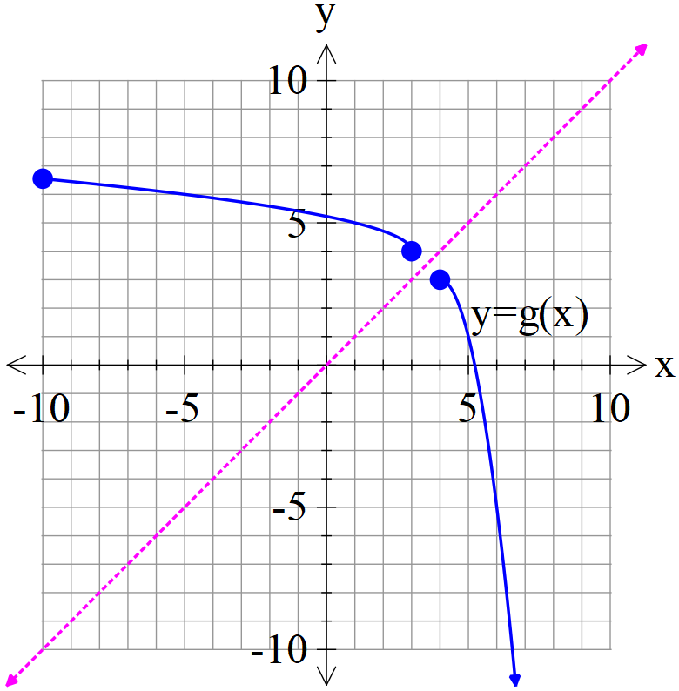

Specific behaviours
✓ reflected in line y=x
✓ shows pt (3,4)
✓ y less than 7

- Given that , determine the defining rule for and its domain. (3 marks)

Solution
Specific behaviours
✓ rearranges x and y
✓ states rule
✓ states domain

Question 6 (11 marks)

Consider the function below.
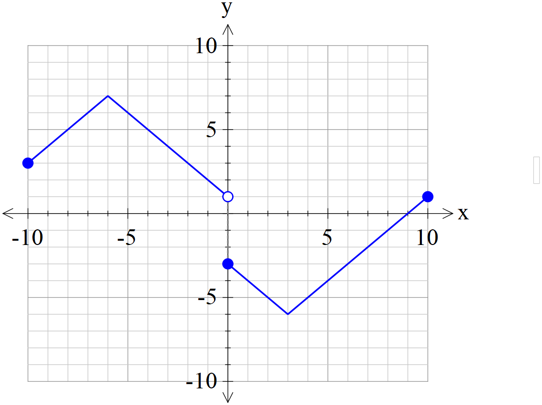
Sketch the following functions showing all major features.
- (2 marks)

Solution
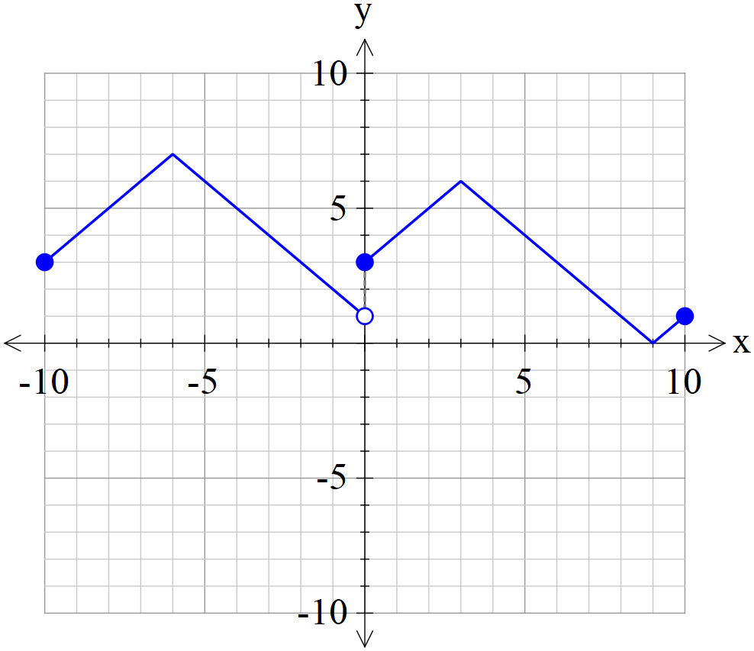

Specific behaviours
✓ shows left is unchanged
✓ reflects right in x axis

- (3 marks)

Solution
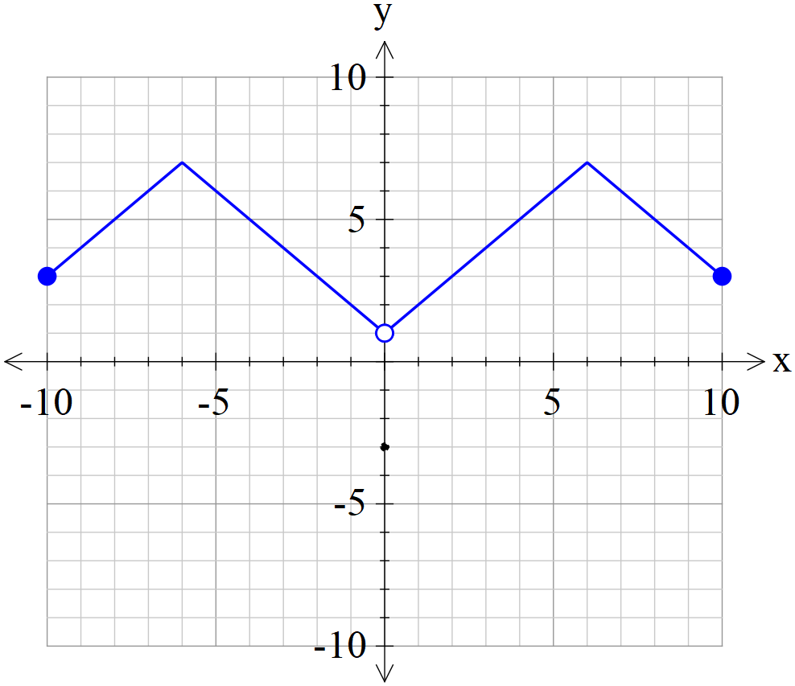

Specific behaviours
✓ uses left side
✓ reflects to give new right side
✓ shows open circle on y axis and y intercept (0,-3)

- (3 marks)

Solution
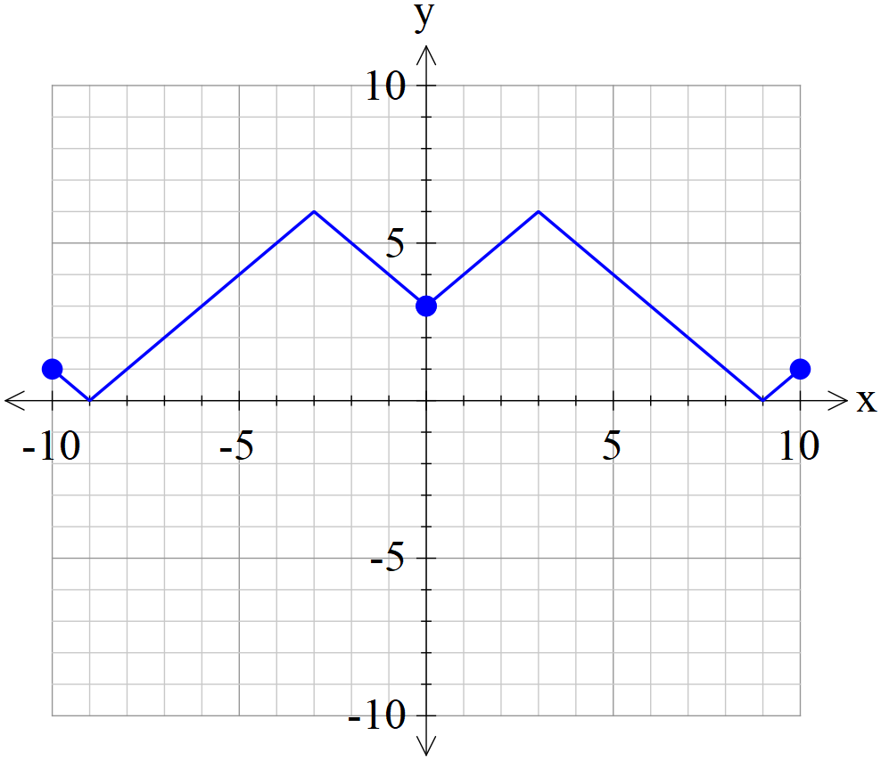

Specific behaviours
✓ uses right side
✓ reflects in x axis
✓ reflects in y axis for new left

- (3 marks)

Solution
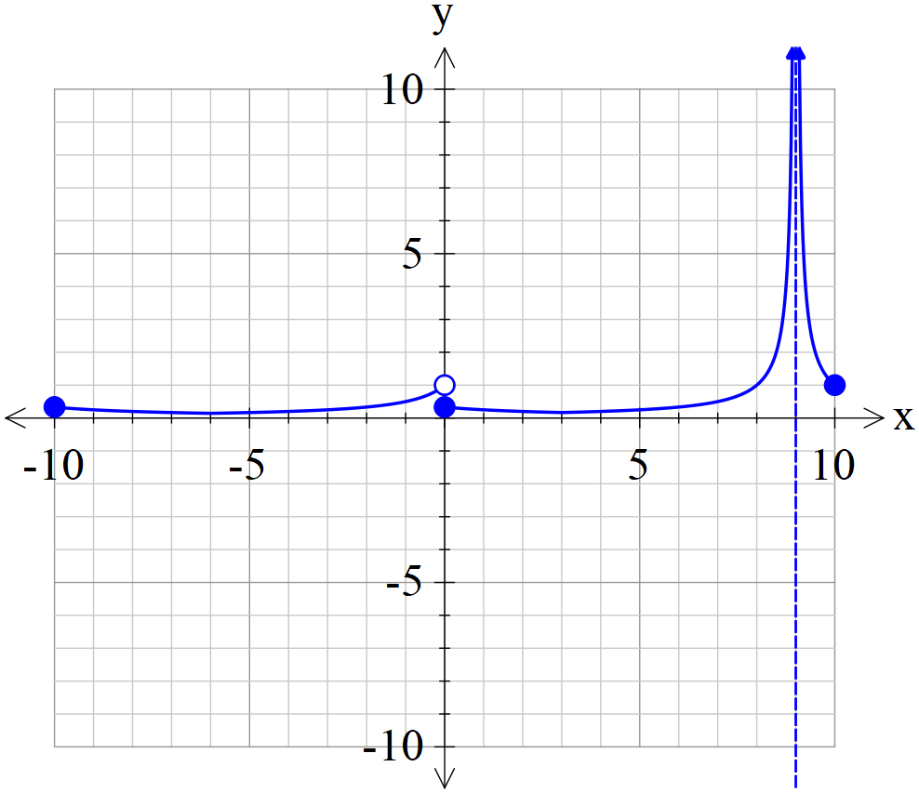

Specific behaviours
✓ shows asymptote with curve either side above x axis
✓ shape
✓ y intercept and open circle

Question 7 (6 marks)

Using the substitution , evaluate the integral . (simplify)

Solution
Specific behaviours
✓ uses du/dx
✓ changes limits
✓ obtains integral in terms of u only
✓ uses partial fractions
✓ obtains anti-derivative and subs limits
✓obtains final value simplified
NOTE: Follow through only if partial fractions used)

Additional working space
Question number:

Additional working space
Question number:

Additional working space
Question number:

